
SHIRE HIGHLANDS EDUCATION DIVISION
2026 MALAWI SCHOOL CERTIFICATE OF EDUCATION MOCK
EXAMINATION

PHYSICS
Subject Number: M164/II
Wednesday, 18th March Time Allowed: 2 hr sessions
10:00am onwards
PAPER II
(40 marks)
Question Number | Tick if answered | Do not write in these columns
TOTAL

Instructions
- This paper contains 6 pages. Please check.

- Write your Name on each page of your Answer Book

- Answer all four questions in the spaces provided.

- Use of a scientific calculator is allowed.

- The maximum number of marks for each answer is indicated against each question.

- In the table provided on this page, tick against the question number you have answered.

- At the end of the examination, hand in your paper to the invigilator

© 2026 SHED MOCK
Turn over

Section A (20 Marks)
- Describe an experiment that could be done to determine the density of cooking oil using Archimedes’ Principle.

______________________________________________________________________________________________________________________________________________________________________________________________________________________________________________________________________________________________________________________________________________________________________________________________________________________________________________________________________________________________________________________________________________________________________________________________________________________________________________________________________________________________________________________________________________________________________________________________________________________________________________________________________________________________________________________________________________________________________________________________________________________________________________________________________________________________________________________________________________________________________________________________________________________________________________________________________________________________________________________________________________________________________________________________________________________________________________________________________________________________________________________________________________________________________________________________________________________________________________________________________________________________________________________________________________________________________________________________________________________________________________________________________________________________________(10 marks)
- With the aid of a well labelled diagram, describe an experiment that can be done to investigate whether electromotive force induced in the secondary coil of a transformer is affected by the number of turns in the coil.
_______________________________________________________________________________________________________________________________________________________________________________________________________________________________________________________________________________________________________________________________________________________________________________________________________________________________________________________________________________________________________________________________________________________________________________________________________________________________________________________________________________________________________________________________________________________________________________________________________________________________________________________________________________________________________________________________________________________________________________________________________________________________________________________________________________________________________________________________________________________________________________________________________________________________________________________________________________________________________________________________________________________________________________________________________________________________________________________________________________________________________________________________________________________________________________________________________________________________________________________________________________________________________________________________________________________________________________________________________________________________________________________________________________________________________________________________________________________________________________________________________________________________________________________________________________________________________________________________________________________________________________________________________________________________________________________________________________________________________________________________________________________________________________________________________________________________________________________________________________________________________________________________________________________________________( 10 marks)

SECTION B (20 Marks)
- You are provided with a convex lens,100cm ruler, lens holder,screen, candle and matches in a box.
- Arrange the apparatus as shown in figure 1
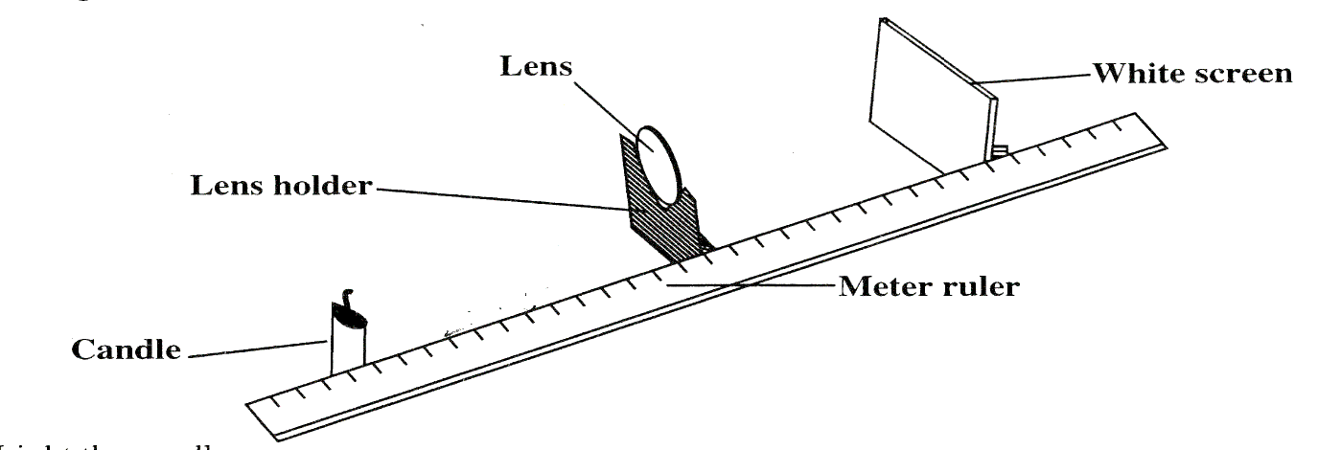
Figure 1
- Light the candle
- Place a candle at a distance of 20cm from the lens
- Adjust the position of the candle until you obtain a clear and focused image on the screen.
- Measure and record image distance,V, from the image to the centre of the lens in table 1.
- Repeat steps a-d using object distances of 30cm, 40cm and 50cm respectively.
Table 1
Object distance(U) cm | Image distance(V) cm | $$\frac{1}{U}$$ | $$\frac{1}{V}$$
20
30
40
50
( 5 marks)
- Complete columns for $\frac{1}{U}$ and $\frac{1}{V}$
- Plot a graph of $\frac{1}{V}$ against $\frac{1}{U}$ ( 4 marks)
- From the graph, find the value of the $\frac{1}{V}$ when $\frac{1}{U}=0$ ( 1 mark)

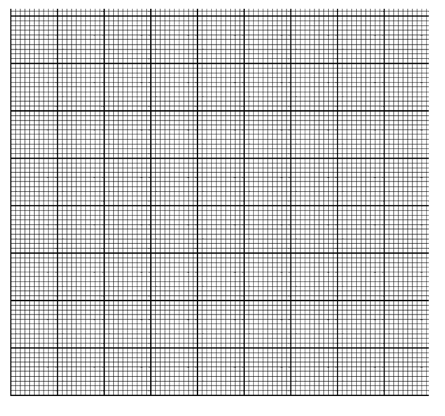
- You are provided with a spring balance, a 200g wooden block, wooden ramp X and a wooden ramp Y.
- Arrange the apparatus as shown in figure 2.
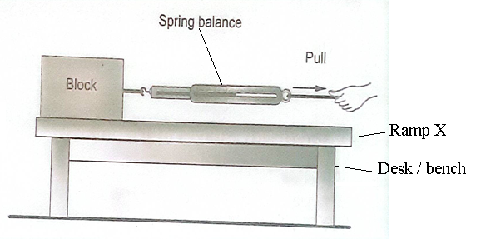
Figure 2
- Pull the spring balance gently until the wooden block is just about to move.
- Record the spring balance reading in Table 2.
Table 2
Ramp | Spring Balance Reading (N)
X
Y
(2 marks)
- Calculate the coefficient of static friction force for ramp X.

( 3 marks)
- Repeat steps a to c using ramp Y
- Calculate the coefficient of static friction force for ramp Y

( 3 marks)
- Compare the coefficients of static friction force for ramps X and Y.
______________________________________________________________________________________________________________________________________________( 1 mark)
- Draw an appropriate conclusion for the experiment
_________________________________________________________________________________________________________________________________________________________________________________________________________________________________
( 1 mark)

END OF QUESTION PAPER

